Title: Achieve Global Scalability: Implementing Global Tables in AWS DynamoDB

Introduction:

For applications requiring global scalability and low-latency access to data, AWS DynamoDB offers the Global Tables feature. With Global Tables, you can replicate your DynamoDB tables across multiple AWS regions, ensuring data availability and performance across the globe. In this blog post, we will explore the steps involved in implementing Global Tables in AWS DynamoDB. Let's dive in!

Step 1: Access the DynamoDB Console Log in to the AWS Management Console and navigate to the DynamoDB service. This is where you can manage your DynamoDB tables.

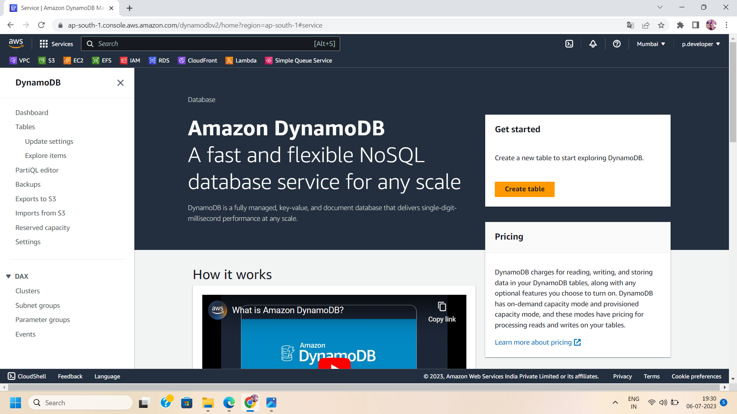

Step 2: Select the Desired Table From the DynamoDB console, choose the table that you want to convert into a Global Table. Ensure that the table structure and data are suitable for replication across regions.

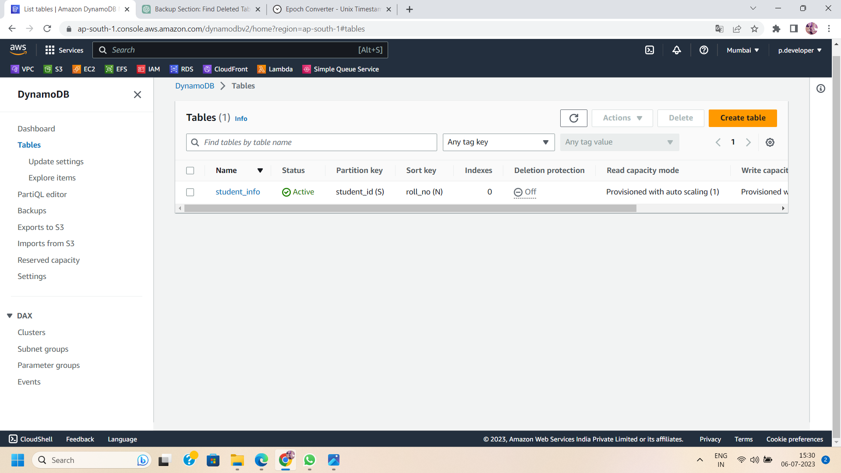

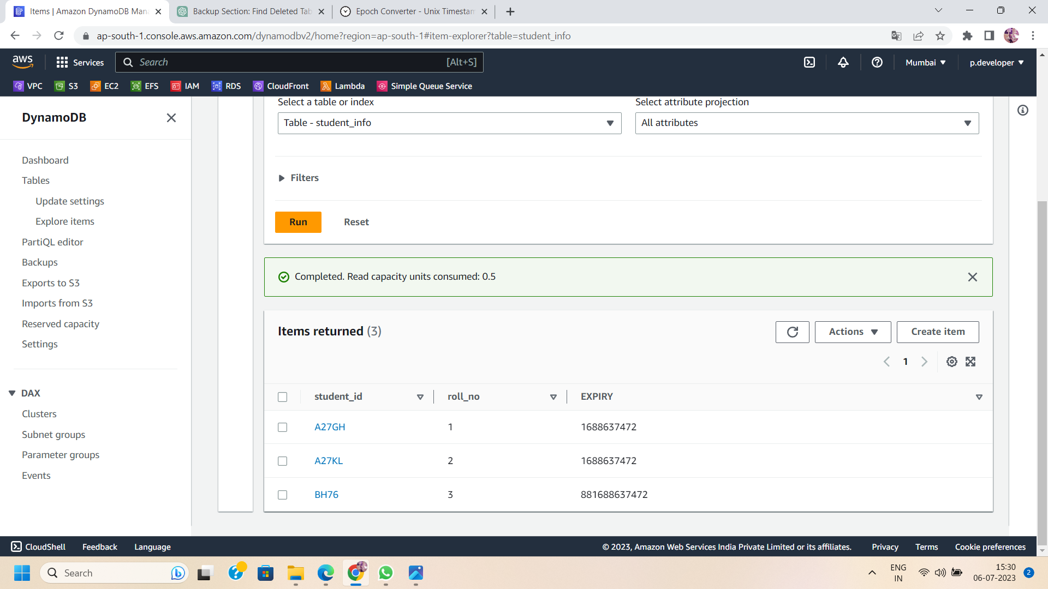

Step 3: To enable the DynamoDB stream settings for the selected table, navigate to the table overview and click on the "Exports and Streams" button. This step is necessary before enabling global table replicas.

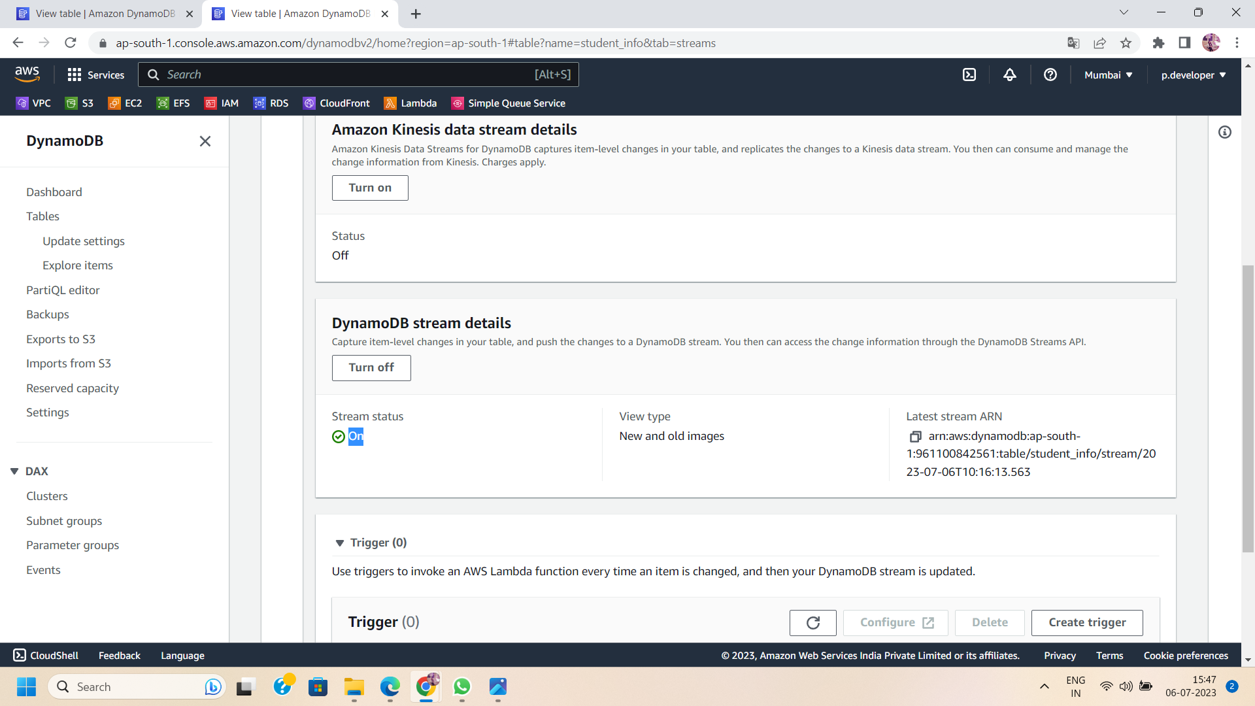

Step 4: Open Table Settings::

In the table overview, click on the "Manage Global Tables" button to access the Global Tables settings for the selected table.

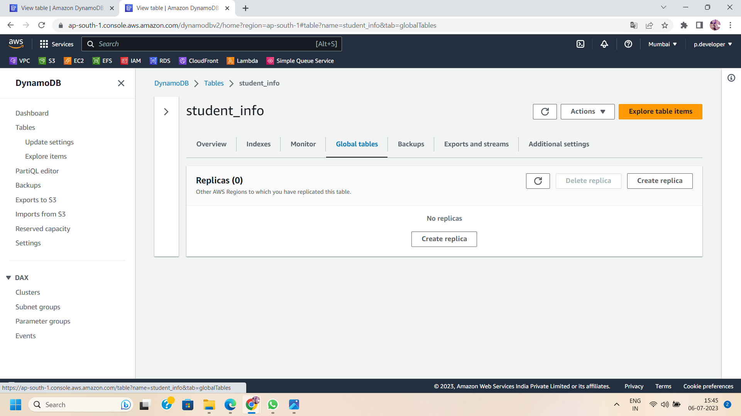

Step 5: Enable Global Tables Within the Global Tables settings, click on the "Create replica" button to enable global replication. This will initiate the process of creating a Global Table.



Step 6: Select Additional AWS Regions:

Choose the additional AWS regions where you want to replicate your DynamoDB table. Consider selecting regions that are geographically closer to your users or where you anticipate high demand for your application.

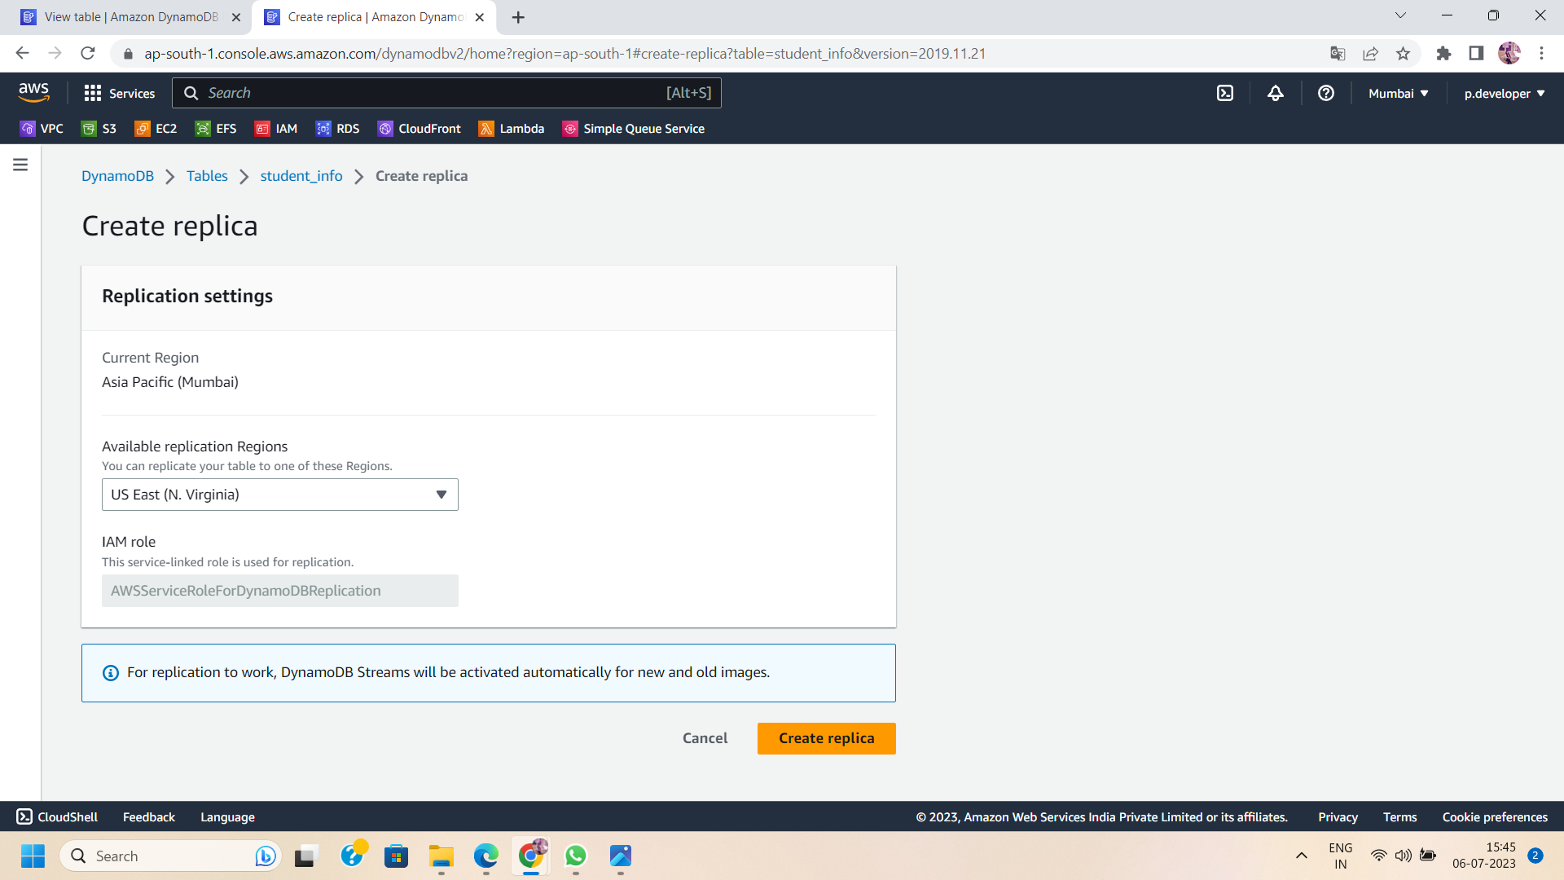

Step 7: Review and Confirm Settings:

Review the settings you have configured for your Global Table. Ensure that the regions, capacities, and other parameters are accurately set. Confirm your choices to proceed with creating the Global Table.



Step 8: Monitor and Test Global Table Replication:

Once the Global Table creation process is complete, monitor the replication status in the DynamoDB console. Verify that the data is being replicated across the selected regions and that the tables are synchronized.(e.g., global table is successfully replicate in N.Virginia region)

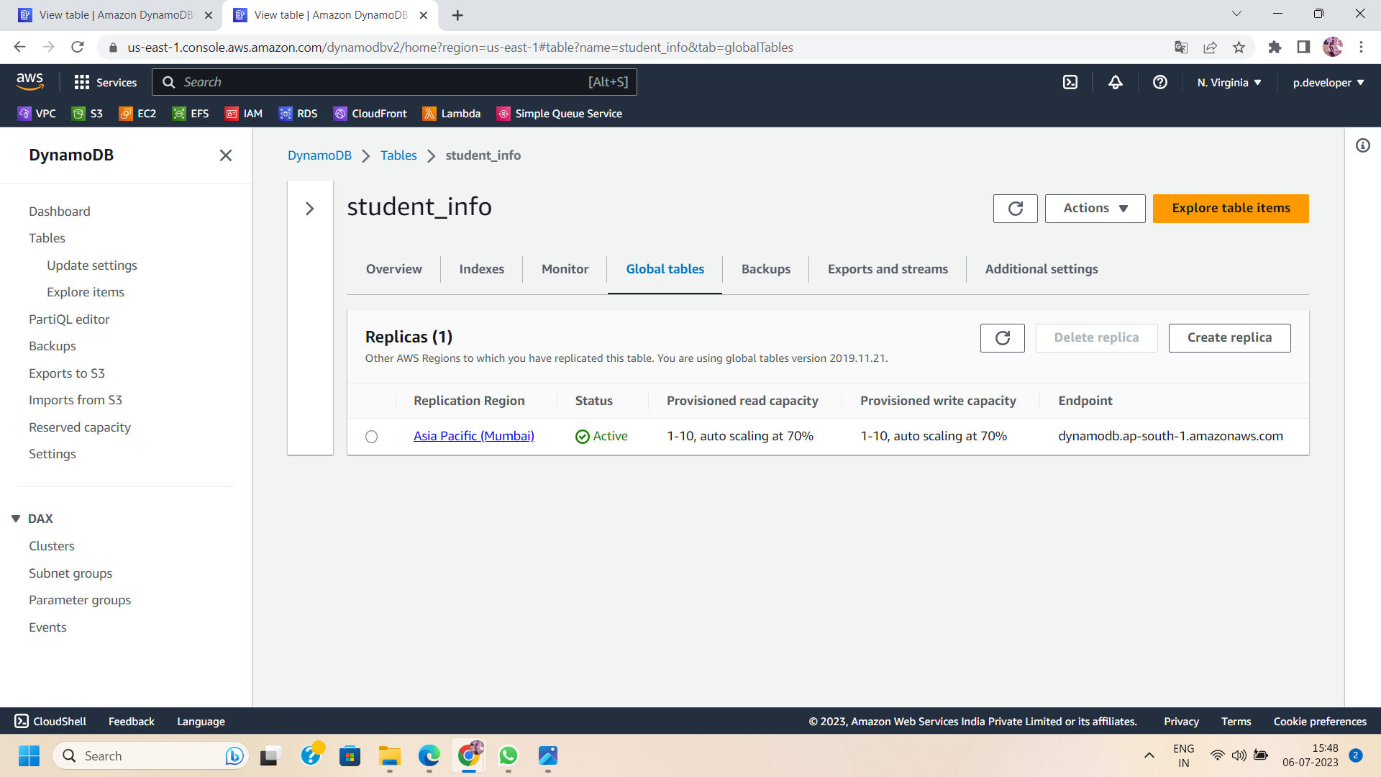

Step 9: Utilize the Global Table:

With the Global Table in place, you can now leverage its benefits. Your application can seamlessly access the replicated tables in different regions, providing low-latency access to data and ensuring high availability.

Conclusion:

Implementing Global Tables in AWS DynamoDB enables global scalability and data availability for your applications. By following the steps outlined in this blog post, you can configure a Global Table and replicate your DynamoDB table across multiple AWS regions. Embrace the power of Global Tables to achieve low-latency access, enhance performance, and provide a seamless user experience worldwide. Leverage AWS DynamoDB's Global Tables feature to take your application's scalability to new heights and conquer the global market.